U3A Science Seminar – 2019
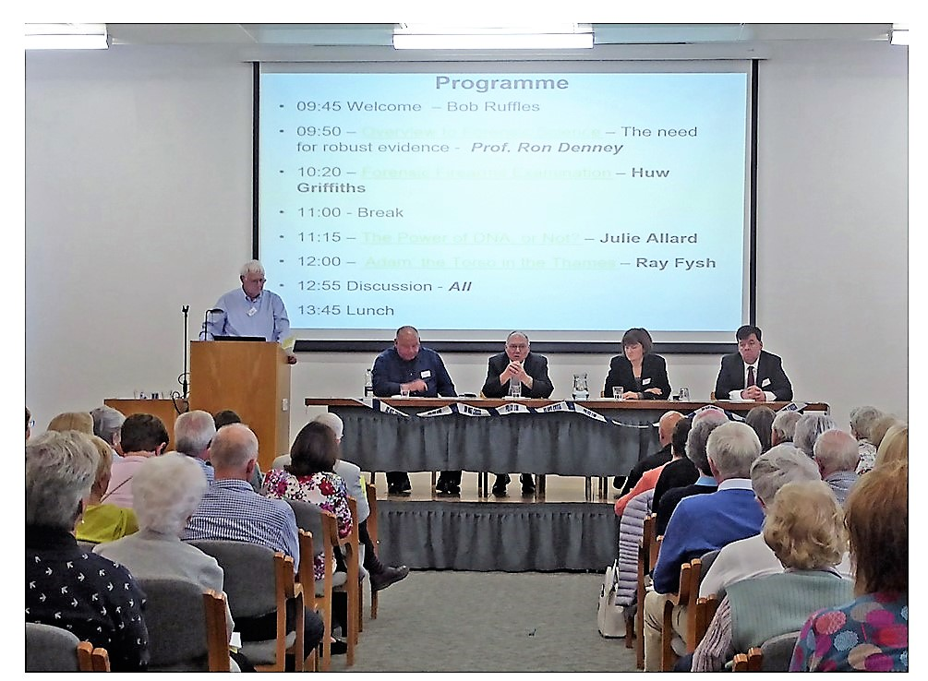

On 5 June, Sevenoaks U3A Science Group held their annual seminar at the East Malling Research Orchards Conference Centre on the theme of Forensics: The Expert Witnesses. This hugely popular topic was heavily oversubscribed and the fortunate 191 attendees were treated to four excellent presentations covering: the origins of forensic science (Professor Ron Denney): firearms (Huw Griffiths): the use of DNA analysis (Julie Allard); and, an investigation into a dismembered body found in the River Thames (Ray Fysh). All speakers had a wealth of experience, ranging from 30 to 45 years, with much of their time spent working for the Forensic Science Service, which was controversially disbanded in 2012. Attendees came from U3As across Kent, in addition to Sevenoaks, participating in a lively question and answer session chaired by Professor Denney. Everyone departed with a much better understanding of the role of “real forensic scientists” involving collaboration across a broad spectrum of technologies including Chemistry, Physics, Biology, Geology, Psychology and Meteorology, combined with persistence and intellectual curiosity.
Dr Tony Sinden

